PHASE 3 – Creating UI Policies and Dependency
Configure dynamic form behavior so fields become mandatory or read-only when required, and configure dependent choices for Category and Subcategory.

UI Policy 1 – Short Description Mandatory
1. Navigate to All menus → UI Policies.
2. Click New.
3. Table: Employee Raise Issue.
4. Short description: When the state changes to New, Short description is mandatory.
5. Condition: State is New.
6. Save the policy.
7. Under UI Policy Actions, click New.
8. Field: Short description; Mandatory: True; leave Visible and Read only unchanged.
9. Submit and update the policy.

UI Policy 2 – Number Read Only
1. Create another UI Policy for Employee Raise Issue.
2. Leave the filter condition empty.
3. Save the policy.
4. Add a UI Policy Action for Number.
5. Set Read only: True.
6. Leave Mandatory and Visible unchanged.
7. Submit and update.

Creating Category → Subcategory Dependency
1. Open the Employee Raise Issue table form.
2. Right-click Subcategory and select Configure Dictionary.
3. Open Advanced view.
4. Set Dependent field to Category.
5. Configure the choice values for Subcategory according to Category.

Dependency Mapping
- Network → VPN
- Hardware → Laptop
- Software → Server
- Access → Forgot password

Validation
Reload the form, change State to New, and verify that Short description becomes mandatory. Verify that Number is read-only and that Subcategory options change based on Category.
Short description Mandatory
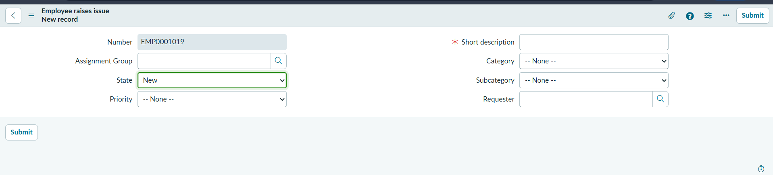
Number read-only policy
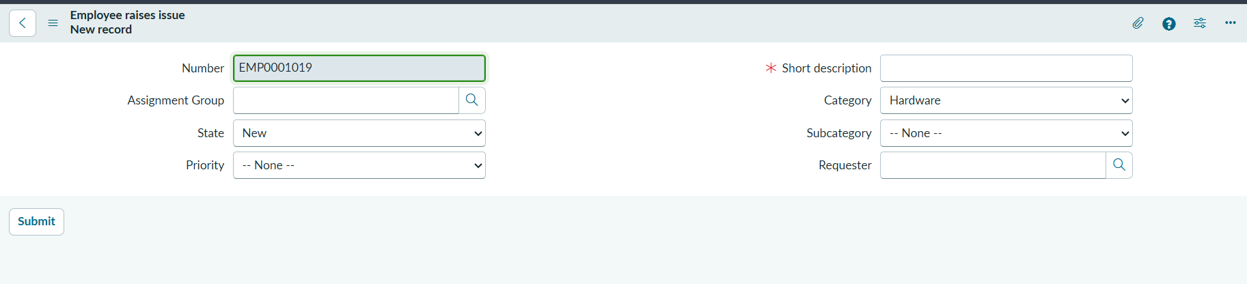
Dictionary dependency configuration
